**✅ High-Level Architecture of Content-Based Recommendation Systems**

**📘 Definition**

A **Content-Based Recommendation System (CBRS)** is a type of recommender system that suggests items to a user based on the features of items they have shown interest in before.  
It uses the **attributes or content** of items (like genre, category, keywords, etc.) and compares them with the **user's profile** to recommend similar items.

**🏗️ High-Level Architecture – Main Components**

A typical content-based recommender system has the following components:

**1. User Profile**

* Represents the user's preferences and interests.
* It is created using:
  + Items previously liked or rated by the user
  + Past interactions like views, clicks, purchases, or time spent
* Can be static or dynamically updated.
* Stored as a vector of preferred item features.
* Example: A user likes action and thriller movies → Profile = {action: 0.9, thriller: 0.8, romance: 0.2}

**2. Item Profile**

* Describes each item using a set of features (also called **attributes**).
* Each item is represented as a **feature vector**.
* Examples:
  + A movie → {Genre: Comedy, Actor: Tom Hanks, Director: Spielberg}
  + A news article → {Keywords: AI, Technology, Startups}
* Item profiles are often built using techniques like:
  + TF-IDF for text data
  + Image tags for visual content
  + Metadata extraction

**3. Feature Extraction Module**

* Automatically extracts relevant features from:
  + Item content (text, images, audio)
  + Metadata (title, tags, category, price)
* Techniques used:
  + Natural Language Processing (NLP) for text
  + Image processing (if visual content)
  + Audio signal processing (for music)

**4. User Profile Learning / Updating Algorithm**

* Learns what kind of features the user prefers.
* Updates the user profile when new feedback or interactions are received.
* Techniques used:
  + Weighted average of item features
  + Machine learning classifiers (Naive Bayes, Decision Trees)
  + Logistic Regression
* The learning can be **explicit** (from user ratings) or **implicit** (from click or view history).

**5. Similarity Engine**

* Compares the **user profile vector** and **item profile vector**.
* Computes similarity score between the two.
* Common similarity measures:
  + **Cosine Similarity** (most popular)
  + **Euclidean Distance**
  + **Jaccard Index**
* The higher the similarity score, the more relevant the item is to the user.

**6. Recommendation Engine**

* Ranks all candidate items by similarity score.
* Selects the top-N items with the highest scores.
* Filters out items already seen or rated by the user.
* Final list of recommendations is shown to the user.

**7. Feedback Module**

* Collects user feedback (either **explicit** like ratings, or **implicit** like clicks, scrolls, time spent).
* Helps in continuously improving the user profile.
* **Reinforcement learning** can also be used for feedback-driven updates.

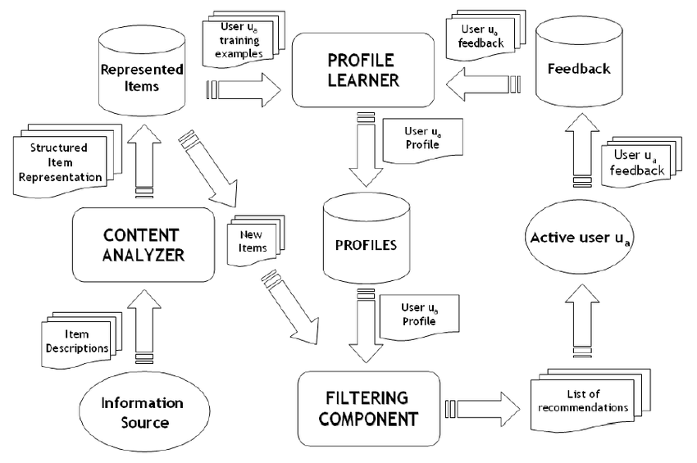**🔄 Flow of Interaction Between Components**

**📈 Example Scenario**

A user reads 5 articles about **machine learning** and **artificial intelligence**.  
The system:

* Learns that the user likes AI topics.
* Builds a user profile with keywords like "machine learning", "AI", "data".
* Scans new articles with similar keywords.
* Recommends new articles on **deep learning**, **AI trends**, etc.

**✅ Advantages of Content-Based Filtering**

* Personalized to individual users.
* No need for data from other users (works even in **cold-start** for new users).
* Can explain why an item was recommended (based on features).
* Easy to update user profiles with new feedback.

**❌ Disadvantages / Challenges**

* **Over-specialization**: Keeps recommending similar items, lacks diversity.
* **Cold start for items**: New items with missing or poor metadata won't be recommended.
* Limited ability to **introduce novelty** or **serendipity**.
* Can't leverage group behavior or social trends (unlike collaborative filtering).

**🧠 Improvements and Enhancements**

* **Hybrid Systems**: Combine content-based filtering with collaborative filtering.
* **Context-aware recommendations**: Use time, location, or mood as additional inputs.
* **Diversity Boosters**: Algorithms that balance relevance with novelty.

**📝 Conclusion**

The high-level architecture of content-based recommendation systems relies on **matching item features with user preferences**.  
By building **user profiles**, **item profiles**, and using a **similarity engine**, the system can provide **personalized** and **relevant** suggestions.  
Though it has some limitations, content-based systems are effective, especially when user interaction history is available.